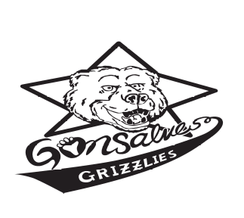Grizzly Gazette

Fall/Winter 2011

Joe A. Gonsalves Elementary School

Robert Benko, Principal
Sherry Becker and Nadia Jaser-Cendejas, Staff Advisors

Samantha Yao, Editor

A Message From the Principal…
Hello Gonsalves Grizzlies:
I’d like to start off by thanking everyone who is part of our Gonsalves Community for an outstanding start to the school year. So much has already happened including a great “Back to School Night”, a successful membership drive, Monday morning Spirit Assemblies, after-school programs, Recognition Award Assemblies, Sack Lunch Days, our “Grizzly Fun Run”, Orange County Performing Arts assemblies and much more. A special thank you goes out to all those involved in our Fall Festival for the Fine Arts. The donations from this event and from the Booster Club are helping support our Fine Arts program (see Fine Arts section). And of course, let’s not forget the learning in the classrooms that has been happening since school started as we all continue to strive to provide the best academic experience for all our students. With all this being said, there is still more to come. I look forward to a great year of continued academic achievement along with the many special school experiences that make Gonsalves a special place to be.

About Our Fine Arts Program…
Thank you to everyone for helping to support our Fine Arts Program. Our music teacher, Mrs. Lewis, is teaching the class which features a Fine Arts survey, including Music, Theater, Dance and Visual Arts. In the area of Visual Arts, students are learning basic concepts and vocabulary, and each student has created artwork that demonstrates his or her understanding and creative use of recently learned concepts. Several grade levels just completed 'interior' work in preparation for beginning Theater. Given a series of settings and instructions, students created their own individual journeys using the 'mind's eye' to take stock of their own awareness of their five senses. After the winter break, we will turn to some basics in Dance. Not only will everyone dance a bit, we'll take a look at the origins, history and evolution, and cultural importance of dance from around the world. Music continues to be scheduled on the week opposite the 'Arts' rotation. Our longstanding format for music continues with grade levels coming as a whole and learning music across genres, cultural origins, and often in support of learning about seasonal events. The Fine Arts rotation requires that each student bring only two things: good manners and a willingness to try. Gonsalves students are well prepared in both ways!

Booster Club Update

By Chris Lim Yao, President
The Gonsalves Booster Club is a non-profit volunteer organization consisting of the teachers, staff and parents of Gonsalves students. As a group, we aim to provide additional activities as well as the volunteer support to augment and enhance the educational experience of our students here at Gonsalves Elementary. Funds raised during the year help pay for supplemental activities such as music, P.E., fine arts, field trips, theater and educational assemblies, as well as various special events throughout the school year.


Membership Drive
A BIG thank you to all the staff and parents for all the generous membership donations, which helped us reach 96% of our membership goal. 12 classes reached 100% membership and enjoyed yummy ice cream parties!

Grizzly Fun Run
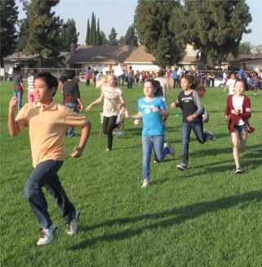
On your mark, get set, GO! The Grizzly Fun Run took place on October 26th, and all our students had a lot of fun making it through the obstacle course that bright, sunny morning. 172 students who raised at least $100 enjoyed a wonderfully entertaining magic show, 111 students who brought in $200 or more went cosmic bowling with Mr. Benko, and 49 students who raised at least $350 will be whisked in a limousine for delicious lunch at In-N-Out Burger. Go Grizzlies!

Fall Festival for Fine Arts
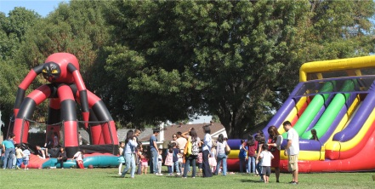
Everybody enjoyed a fun-filled day at The Fall Festival for Fine Arts on October 29th with scrumptious food from premier gourmet food trucks, wonderful entertainment from various artists, as well as endless array of activities and games. All the support in helping to facilitate the funding of the Gonsalves fine arts program is much appreciated!

School Cents Program

Help our school win a share of $50,000. Just shop and log receipts from any of Lakewood, Los Cerritos and Stonewood Centers stores and restaurants between September 15, 2011 and May 15, 2012. Remember to tell your family, friends, neighbors and co-workers to log their receipts at Guest Services anytime during the program. Our school earns five points for every dollar spent, with lots of additional bonus points opportunities that will be communicated to our families throughout the school year through emails and flyers. For this holiday season, we hope to donate many holiday dinners to the Long Beach Rescue Mission through the annual Holiday Dinner Drive sponsored by School Cents.

Box Tops for Education
(www.boxtops4education.com)
Box Tops for Education has a long history of supporting schools and children’s education. Don’t forget to clip those Box Tops coupons from hundreds of participating products and earn cash for our school!

Shop for Schools
(www.freshandeasy.com/ShopForSchools)

Fresh&Easy Neighborhood Market will donate $1 to our school for every $20 Fresh&Easy receipt collected now through December 31, 2011. Each receipt must be at least $20 to be counted. Just drop off those receipts in the school office. Remember, the more receipts we collect, the more money our school will earn!

Student Council Update

By Eunice Park, President
Sponsoring many of the school’s activities, Student Council is a group of students representing the school and aiming to simmer a fun and enjoyable year to remember. As well as regularly selling a variety of juice bars after school for a dollar apiece and offering valet drop-off services in the morning, Student Council has chosen to tackle several special activities during the late fall/winter semester.
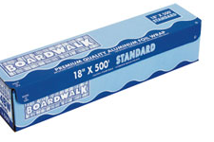
One recent event that is in action right now in this Thanksgiving season is the creation of a Giant Aluminum Foil Turkey. This idea, proposed by Student Council advisor Mrs. Smith, grasps ambitions to become Guinness’s World Record’s largest aluminum foil turkey. If one chooses to participate by bringing in a roll of foil, they can help at lunch to roll the massive turkey with their foil, as well as take part in a snapshot of the completed turkey. Student Council urges you to help Gonsalves become a legend by bringing in your foil today!

To eliminate the constant hassles of buying presents and keeping secret surprises for Mom, Student Council also offers an annual Holiday Extravaganza near Christmas. Supplying plush animals, posters, stencils, key chains, necklaces, and much, much more, Holiday Extravaganza provides an affordable opportunity to shop for the perfect presents to bring a smile to friends, pets, teachers, and family members.
Another event Student Council is considering to host in December or January is Sock It To Me. By bringing in long black tube socks, students can help to support the marines, ensuring the protection of our country. In exchange, students who participate will receive a small treat, such as a pass to attend a movie in the resource center.
Student Council wishes you a great year ahead!

School Assemblies
By Mrs. Hirayama and 3rd graders Ayaan Ekram, Mmasiolu Gamero, and Tobi Yao
Gonsalves students once again had the pleasure of attending outstanding performances by the Segerstrom Center for the Arts and the Amazing School Assemblies through the generous funding of our Booster Club.
On September 16th, our first assembly featured Jacque Nunez, accompanied by Californian Indian dancers. The students learned about the lifestyles of the California’s Acjachemen Nation as Jacque shared her people’s instruments, games and clothing through songs, stories, and hands on interaction.
On October 14th, the students were privileged to experience Southern California’s favorite school assembly entertainer, John Abrams. He used comedy, magic, and a touch of craziness to educate, inspire, and entertain us with his outrageous new “Random Acts of Character” performance. It was exciting, creative and everyone learned about character traits that help us to become better people.
On October 28th, the students were led through a journey in their imaginations as they discovered the important aspects of story writing with The Imagination Machine performances of “Who, What, Where” and Write Away”. Everyone had the opportunity to participate in improvisational games that helped to develop characters, settings and plot lines. After the students will have written their stories, one or two of them will be selected and will be performed by The Imagination Machine in January.
All of our assemblies are assisting our students’ learning in literacy, language development, critical thinking while promoting creativity and innovation.

Spotlight on Third Grade

By Ms. Yoon, Mrs. Ahmad,

and Mrs. Hirayama
Third graders have been working hard on beginning to master third grade standards in reading, math, science, and social studies. Students studied the solar system in an earth science unit in September. In October students studied landforms and regions of California. In math, students have finished units on place value, addition, subtraction, and multiplication, and are preparing to begin a unit on geometry. Using context clues to determine the meanings of unknown words has been a big focus in reading, as well as many other grammar and comprehension standards. Third graders are excitedly awaiting their field trip to the Cerritos Center for the Performing Arts to see The Magic School Bus Live: Climate Challenge, after working hard to prepare for and pass their Language Arts Benchmark Test.

Feature on Fourth Grade

By Mrs. Jaser-Cendejas, Ms. Kung,

and Ms. Nicholson
Greetings Grizzlies! Fourth Grade at Gonsalves is an exciting time! This is a year of important transitions, as well as one in which the acquisition of new skills is accelerated.
In Fourth Grade we cover a variety of units and themes including:
*California Geography
*California History
*Rocks & Minerals
*Electricity & Magnetism
*Populations & Ecosystems
*Multi-digit Multiplication & Division
*And much more!
We spend a lot of time thinking critically about the world around us! One of our major focus areas in 4th Grade is writing, since 4th grade is the year the State of California tests all children in Writing. We are hard at work learning to write strong narrative essays, summaries, and responses to literature!
Not only are we busy developing our minds, but we also spend time getting physically fit each week. Our motto is "Healthy Kids, Happy Kids"! We work on sports skills with Dr. Randy, and we also run in our 4th grade Running Club. We run for 20 minutes around the track and try to get in as many laps and miles as we can! We set running goals and work hard at improving our times each week.
We also go on field trips to Mission San Juan Capistrano, the Cerritos Center for the Performing Arts, and have the Sea Lab come to Gonsalves for an "at-school" field trip complete with real-life sea animals, games, and even life-science Jeopardy!
One of the major highlights of the year is our California Native American Day! It is a day where we spend time learning about how Native Americans lived in the past; how they used their natural resources; what tools they made and used; what games children played; and much more! We even get to weave real baskets using natural materials!
In Fourth Grade, everyday is a great day for learning something new!


